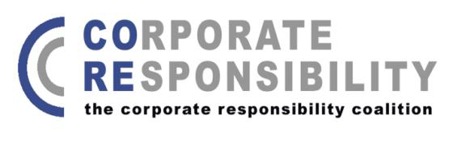
CORE
PRESS RELEASE
UNDER STRICT EMBARGO: WEDNESDAY 17 OCTOBER 2012 00.01 GMT
GOVERNMENT MUST extend extra-territoriality TO CURB CORPORATE ABUSE
Failure to act will lead to business as usual say NGOs
Parliamentarians and NGOs have welcomed a report by a committee of MPs urging the Government to do more to address human rights abuses resulting from the overseas activities of UK businesses.
The Foreign Affairs Select Committee report released today sets out that a forthcoming Government strategy on Business and Human Rights must go beyond providing advice to companies and a reliance on voluntary initiatives to change business behaviour, and should set out the Governmental responsibilities necessary to fulfil its duty to protect human rights.
The report goes on to recommend that the Government consider an extension of extra-territorial jurisdiction to cover actions overseas by businesses based in the UK, or by firms operating under contract to the UK.
The Committee also criticises the UK Government’s position on extra-territoriality, set out in its intervention in Kiobel - v - Shell, a major human rights court case brought in the U.S. by a group of Nigerians, relating to allegations that Shell was responsible for the jailing and ultimate executions of nine Nigerian activists who were campaigning against the company’s operations in the Niger Delta.
Shell’s legal team have used the case to argue that corporations should be exempt from extra-territorial jurisdiction. The UK Government has supported this, stating that ‘US courts should not assert jurisdiction on claims brought by a foreign plaintiff against a foreign country which concern events in a third country.’
Shell’s position has attracted widespread criticism, including from Professor John Ruggie, the former UN Special Rapporteur for Business and Human Rights, who has described it as an attempt to ‘…destroy an entire juridical edifice for redressing gross violations of human rights.’
Commenting on the report, Lisa Nandy MP, Chair of the APPG on International Corporate Responsibility said ‘The Government’s intervention in Kiobel - v - Shell is apparently at odds with its commitment to implement the UN Guiding Principles on Business and Human Rights. All decisions taken by the Foreign Office and across government should be in line with their human rights policy commitments and I am concerned that in this case, as in many others, government has failed to do so.’
Marilyn Croser from CORE, a coalition of NGOs that work on corporate accountability said ‘The Government’s Business and Human Rights Strategy must include commitments to meaningful action to prevent corporate abuse overseas. If Government fails to act, the result will be business as usual. Extending extra-territorial jurisdiction to UK businesses would be a significant step towards improved corporate accountability.’
Peter Frankental, Economic Relations Programme Director at Amnesty International UK said ‘Amnesty International welcomes FAC's recognition that the human rights impacts of UK businesses abroad should not be subservient to commercial and security interests.’
ENDS

