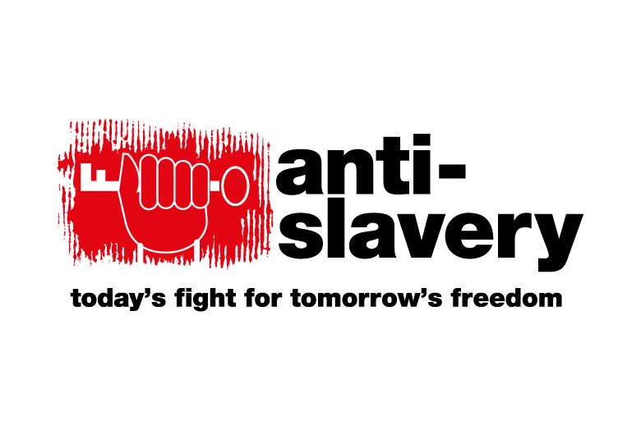
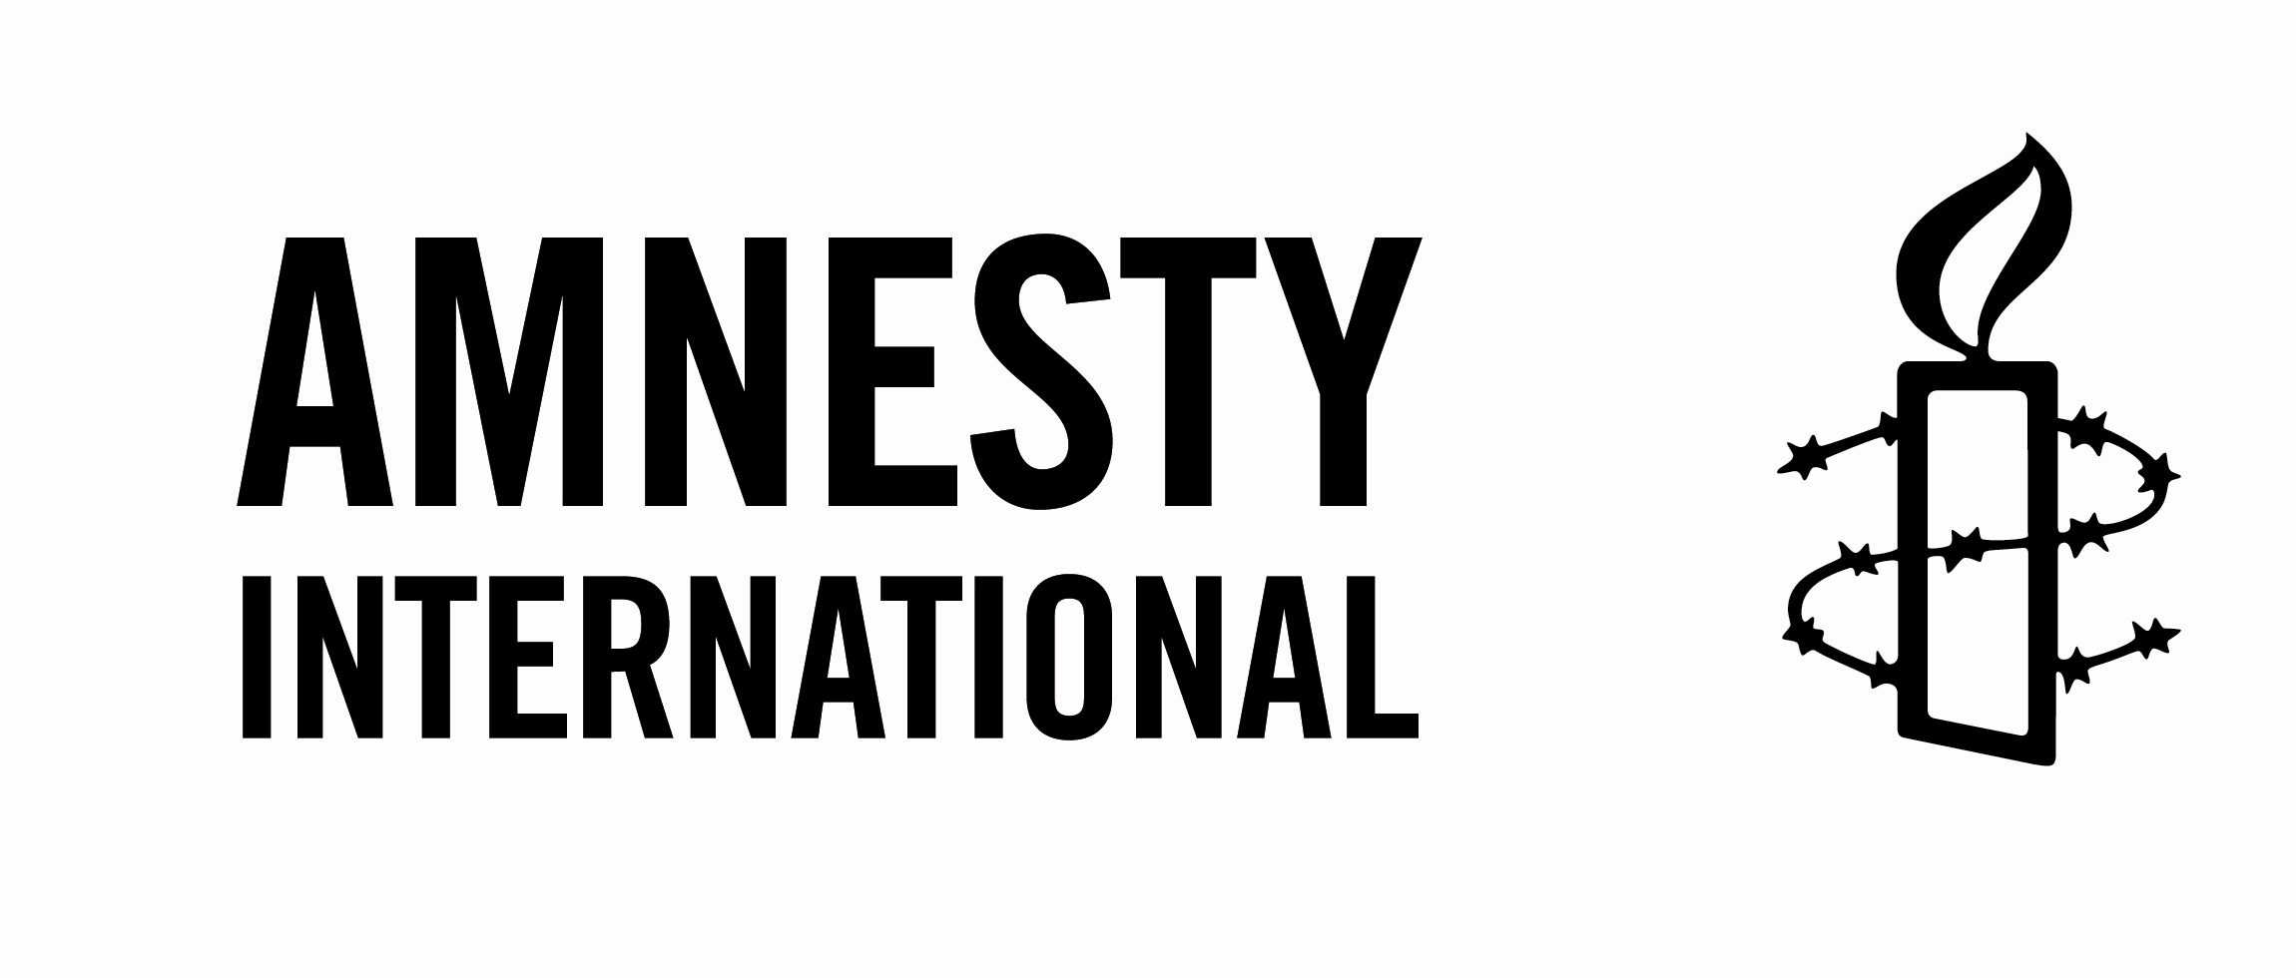

20 April 2017

Priorities for the next government on corporate accountability, responsible business and trade

Commit to continued action on modern slavery and human trafficking including a five-year review of the Modern Slavery Act 2015

Modern-day slavery and human trafficking are urgent challenges facing Britain. According to the International Labour Organisation, modern slavery is an illicit trade worth at least $150 billion (£96 billion) per year that exploits 21 million people globally. The Modern Slavery Act 2015 includes a requirement for businesses to report on slavery and forced labour in their supply chains. This provision is welcome but is yet to drive real change in supply chains. Government must get a real grip of this issue right across Whitehall and drive further progress, including by ensuring proper scrutiny of implementation of the transparency in supply chains provision by businesses, properly resourcing labour inspection agencies to address slavery across the labour market, eliminating the risk of modern slavery in public procurement. The UK should continue to adhere to all EU and Council of Europe legislation relevant to combatting modern slavery.

Reform the law to allow for criminal prosecutions against UK companies for conduct that results in human rights abuses

Between 2004 and 2014 the Business and Human Rights Resource Centre received 303 allegations of serious harms made against 127 UK companies, including a number of repeat offenders. But gaps in the UK’s criminal law framework lead to serious corporate crimes not being investigated and human rights abuses going unpunished. Government should address this by reforming the ‘identification doctrine’, which makes it difficult to attribute liability, especially in large and complex companies because of the need to prove that senior managers intended to commit an offence. Both the Law Commission (in 2010) and the Joint Select Committee on Human Rights (2017) have suggested that this is a barrier to prosecuting large companies and needs to be re-thought. The JCHR has also recommended legislation to create an offence of ‘failure to prevent human rights abuses’ for all companies, including parent companies, along the lines of the relevant provisions of the UK Bribery Act 2010.

Reform corporate governance to protect the environment and workers’ rights

Primary legislation should be enacted to give workers the right to board-level representation in all listed and private companies with 250 or more workers.
In companies of 100 or more workers, workers should be able to trigger board representation rights through their unions or bodies established under statutory consultation procedures.

All companies operating in the UK with an annual turnover of more than £36 million should be required to conduct human rights due diligence throughout their operations, and to report on how they have done so. Section 172(1) of the Companies Act 2006 should be reworded to create a positive obligation on directors to mitigate serious adverse impacts on employees, suppliers, customers, the community and the environment. Directors of companies that cause serious harm to stakeholders should be liable to disqualification.

Non-financial reporting requirements in s.414C of the Companies Act should apply to all businesses with more than 500 employees, regardless of legal form.

Human rights protections must be a central pillar of future trade deals

Once the UK leaves the EU, it will cease to be a party to EU trade deals, and will negotiate new bilateral trade and investment agreements with other countries. The UK should, at a minimum, include in any such agreements the same level of human rights protection as are currently seen in EU trade agreements. Government should undertake human rights impact assessments before entering into future trade agreements, and seek to set higher human rights standards in such agreements, with workable provisions on enforcement, labour rights protection and independent oversight.

ENDS

For more information, please contact Marilyn Croser at the CORE Coalition: marilyn@corporate-responsibility.org

